**ATM CARD MANAGEMENT SYSTEM**

**Team Name:** Beginners

**Team Members:**

* Dave Prades
* Brianna Carlota Tabuena
* Caroline Munar

**Project Description:** This project ATM is on electronic banking outlet that allows costumer to complete basic transaction without the aid of branch representative or teller, ATM are convenient allowing consumer to perform quick self service transaction. Such as deposit, cash withdrawal, and transfer between account. Some of all these fees can be provided by using an ATM operated directly by the banks.

**Features/Functionality:**

* Login
* Show Balanace
* Deposit
* Withdraw
* Transaction

**Basic Classes**

* ATM
* Account/Costumer
* Transaction
* Service

**Class Diagram**

**Team Member Contributio:**

* Dave Prades

-Atm and Account

* Brianna Carlota Tabuena

-Transaction

-Class Diagram

* Caroline Munar

-Class Diagram

-atmID: int

-bankName: String

-location: String

+Atm()

+Bank(atmID : int, bankName : String, location : String)

+getAtmID(); int

+getBankName():String

+getLocation():String

+setAtm()AtmID : int) : void

+setBankName(bankName : String) : void

+setLocation(location : String) : void

+print() : void

+displayBank() : void

+add() : Boolean

+get(searchID) : Atm

+viewAll():void

+printRow() : void

**ATM**

**ACCOUNT**

-id: int

-name: String

-address: String

-acc_num : int;

-pin:int

-accountType : String

-initialDeposit: double

-bank:Bank

+Account()

+Account(bank : Bank, id : int, name : String, address : String, acc_num : int, pin : int, accountType : String, initialDeposit : double)

+getBank(): Bank

+getID() : int;

+getName():String

+getAddress():String

+getAccNum() : int

+getPin() : int

+getAccountType() : String

+getInitialDeposit() : double

+setBank(bank: Bank) : void

+setID(id : int) : void

+setName(Name : String) : void

+setAddress(Address : String) : void

+setAccNum(acc_num : int ) : void

+setPin(pin : int) : void

+setAccountType(accountType : String) : void

+setInitialDeposit(initialDeposit: double):void

+print() : void

+display() : void

+disp():void

+add() : Boolean

+get(searchAccNum) : Account

+get(SearchAccNum, serachPin):Account

+viewAll():void

+printRow() : void

+printRowws() : void

**1**

**0..\***

**1**

**1**

**0..\***

**0..\***

**SERVICE**

**TRANSACTION**

-transactioID-string

-fromAccountNo-String

-toAccountNo-string

-typecode-string

-amount-string

-credits-string

+transaction-(String transactionId, String fromAccountNo, String toAccountNo, String typecode, String amount)

+transaction-(String transactionId, String fromAccountNo, String toAccountNo) +transaction(String typecode, String amount) +getAmount():double

+getTransaction():transaction

+getFromAccountNo():fromAccountNo

+ getToAccountNo:toAccountNo

+getTypecode: typecode

+computeTransaction:Double

-

**Sample Runs**

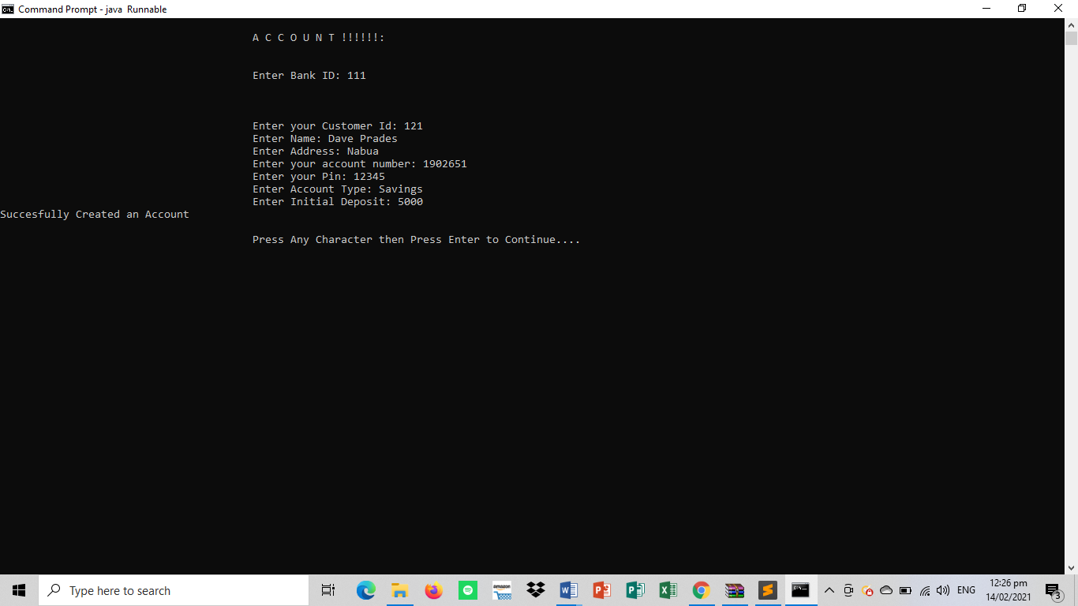Account/Costumer

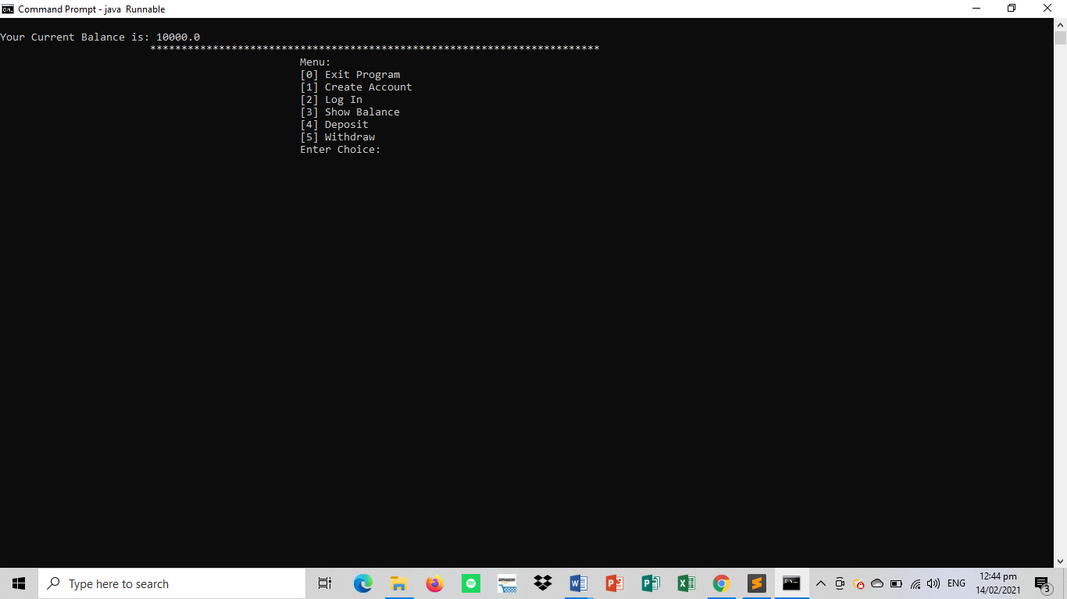Show Balance

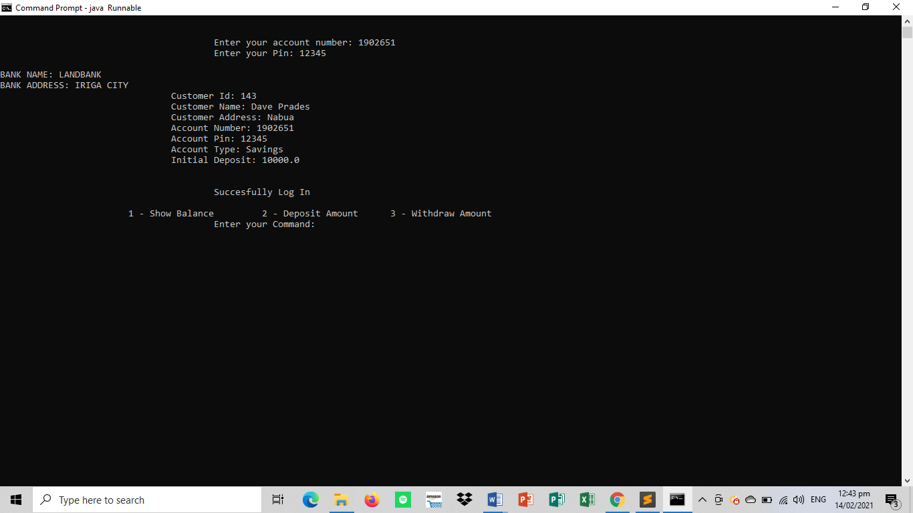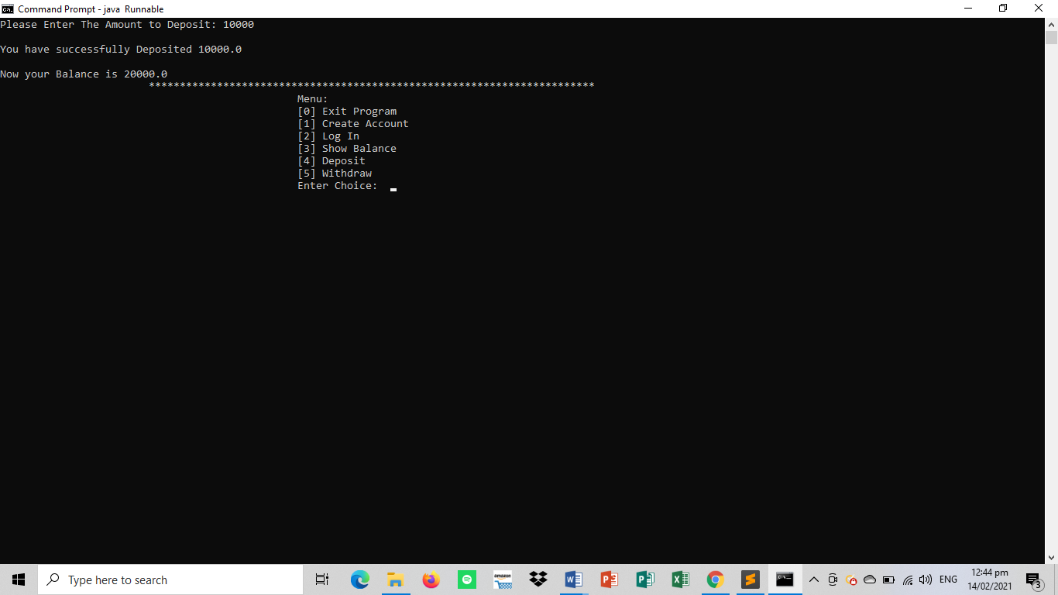Deposit

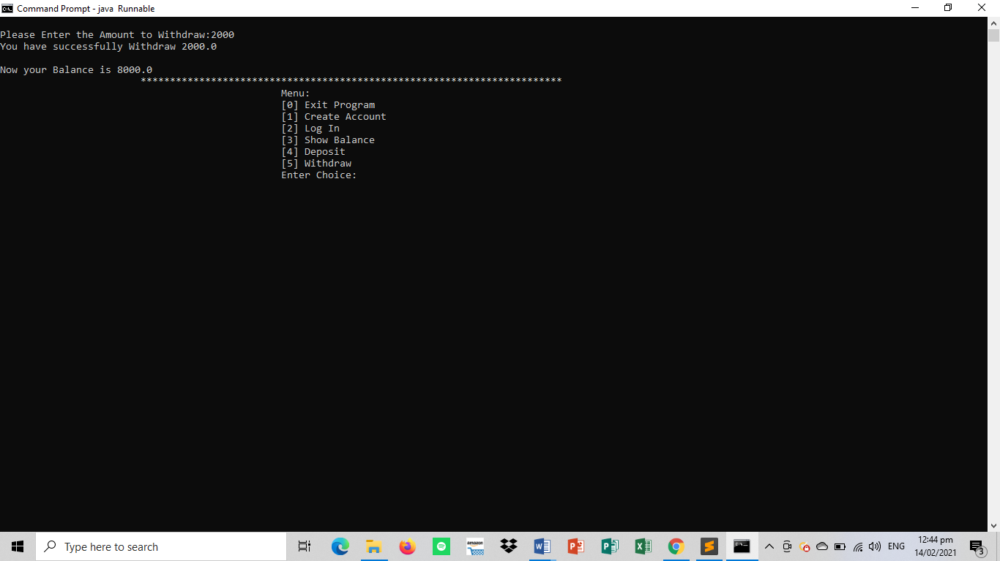Withdraw

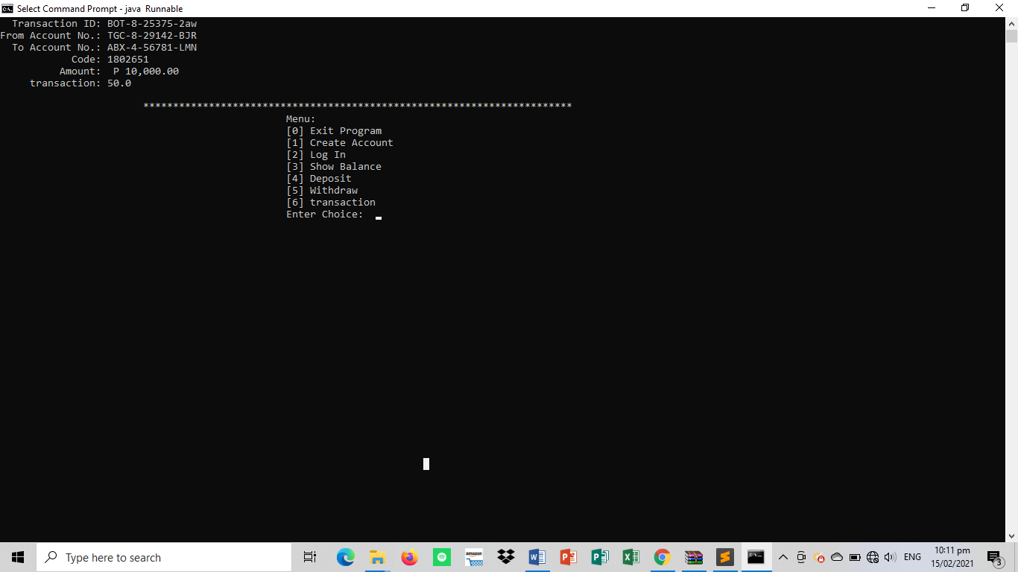Transaction